James Brereton

University Centre Sparsholt,

Sparsholt, Winchester,

James.Brereton@sparsholt.ac.uk

December 15th, 2020

Dear Editors of Applied Animal Behaviour Science

Please find attached for your consideration a paper entitled Optimizing Behavioural Observations: A Comparative Approach to Simulated Sampling Methods ”. In thus study, we compared two commonly-used behavioural methods: pinpoint (instantaneous) and one-zero sampling under three different interval lengths and two conditions in order to determine which method has the lowest error margins. We consider Applied Animal Behaviour Science to be the best vehicle for the publication because of its readership and use by practitioners from many different aspects of animal care. This work has some broad implications that can be used for informing project development for both wild and captive animal research.

We confirm that there are no known conflicts of interest associated with this publication and there has been no significant financial support for this work that could have influenced its outcome.

We have given due consideration to the protection of intellectual property associated with this work and that there are no impediments to publication, including the timing of publication, with respect to intellectual property. In so doing I confirm that I have followed the regulations of my institution concerning intellectual property.

I understand that the Corresponding Author is the sole contact for the editorial process (including Editorial Manager and direct communications with the office). I am responsible for submissions of revisions and final approval of proofs. I have provided a current, correct email address: James.Brereton@sparsholt.ac.uk

Thank you for considering this article for publication. I look forward to hearing your reply.

Sincerely,

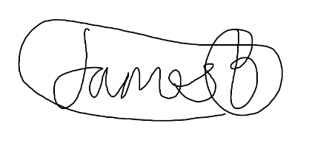

James Brereton